Project Design Phase-II
Data Flow Diagram & User Stories

Date | 31 January 2025
Team Id | LTVIP2026TMIDS36439
Project Name | Toycraft Tales Tableau's vision into Toy manufactures data
Maximum Marks | 4 Marks

Data Flow Diagrams:

A Data Flow Diagram (DFD) is a traditional visual representation of the information flows within a system. A neat and clear DFD can depict the right
amount of the system requirement graphically. It shows how data enters and leaves the system, what changes the information, and where data is stored

Example: (Simplified).
FLOW

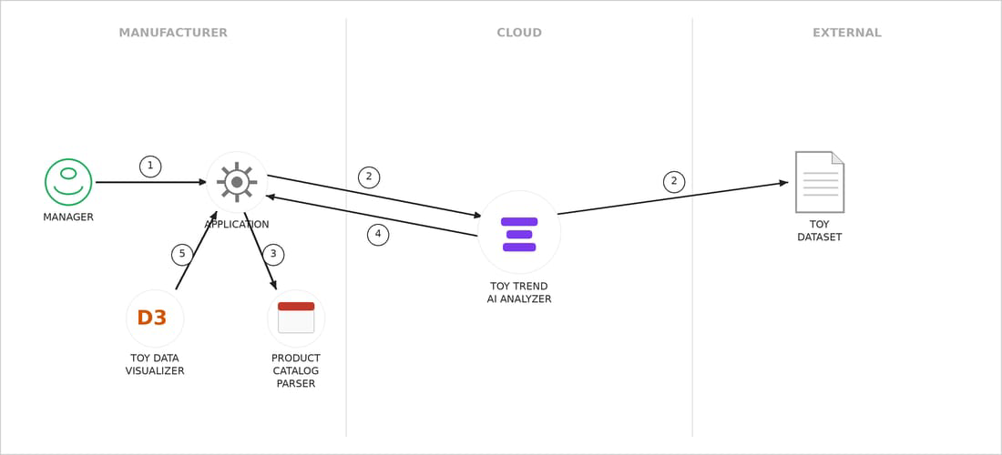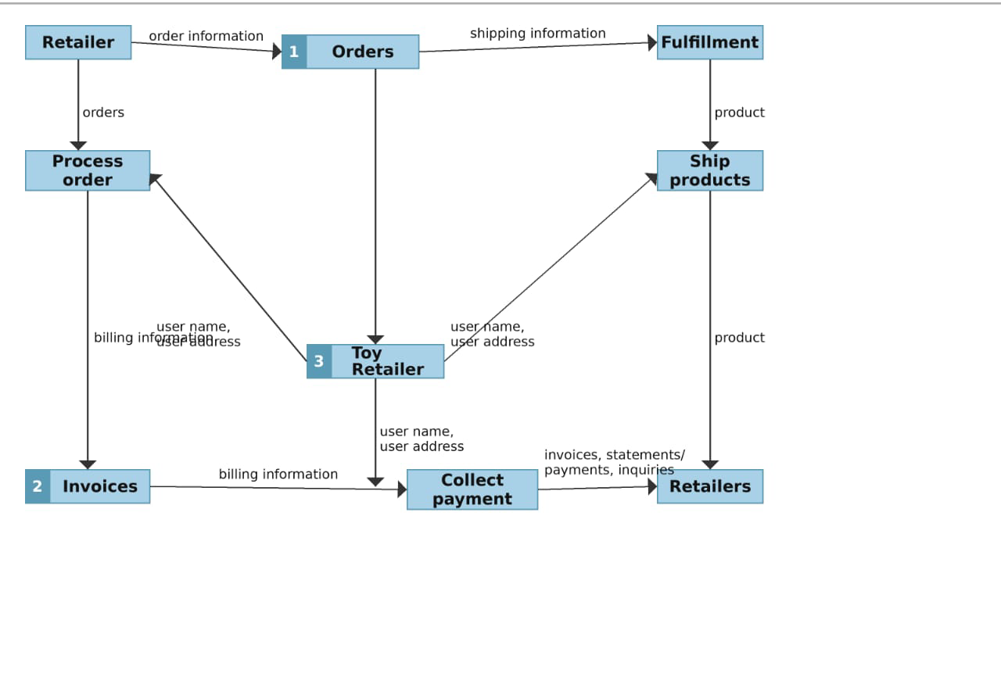

- Request Initiation: The Manager triggers the process by sending a command (1) to the local Application.
- Cloud Analysis: The Application communicates (2) with the Toy Trend AI Analyzer in the cloud, which pulls data from an External Toy Dataset.
- Local Parsing: The Application sends data (3) to the Product Catalog Parser to structure internal product information.
- Data Integration: The AI Analyzer returns the processed trend results (4) back to the central Application.

User Stories

Use the below template to list all the user stories for the product.

User Type | Functional  Requiremen(Epic) | User Story  Number | User Story / Task | Acceptance criteria | Priority | Release
Customer (Web User) | Dashboard | USN-1 | As a user, I can register for the application by  entering my email, password, and confirming my password | I can see a "Top Trends" bar chart that updates based on sales data. | Medium | Sprint-1
Customer (Web User) | Dashboard | USN-2 | As a user, I want to filter toy data by age group to find relevant gift ideas. | The dashboard filters results instantly when an age range is selected. | Low | Sprint-2
Customer Care Executive | Inventory Tracking | USN-3 | As an executive, I want to check real-time stock levels to answer customer availability queries. | I can search for a toy by ID and see the exact stock count across warehouses. | High | Sprint-1
Customer Care Executive | Feedback Analysis | USN-4 | As an executive, I want to see a sentiment chart of toy reviews to identify quality issues. | A word cloud or sentiment bar shows common customer complaints/praise. | Medium | Sprint-2
Administrator | Data Management | USN-5 | As an admin, I want to upload monthly factory production data to update the visuals. | The dashboard reflects new data within seconds of a CSV upload. | High | Sprint-1
Administrator | Strategic Vision | USN-6 | As an admin, I want to view a geographical heatmap to see which regions have low sales. | A map visualization shows sales volume by city/region using color gradients. | High | Sprint-1
Administrator | Cost Analysis | USN-7 | As an admin, I want to compare manufacturing costs vs. retail price to find profit margins. | A scatter plot displays the "Profit Gap" for every toy category. | Medium | Sprint-2

